PRESS RELEASE

COMMUNICATIONS AND MEDIA TEAM OF THE 43RD ASEAN SUMMIT 2023

No.115/SP/TKM-ASEAN2023/ENG/9/2023

Kamala Harris Thanks Indonesia for its Leadership in ASEAN

JAKARTA, 7 September 2023 – Part of the agendas during the 43rd Summit of the Association of Southeast Asian Nations (ASEAN) at the Jakarta Convention Center held on 5—7 September 2023 is bilateral meetings between the leaders of the attending countries. On Wednesday (6 September 2023), US Vice President Kamala Harris met with Indonesian President Joko “Jokowi” Widodo on the sidelines of the ASEAN Summit.

In an official press release by the White House on Thursday (7 September 2023) it was stated that the meeting between the two leaders was held in a relaxed and welcoming atmosphere. Vice President Harris expressed her delight at the warm welcome she received upon her arrival in Jakarta on Tuesday (5 September 2023). The two leaders last met in Bangkok, Thailand, at the Asia Pacific Economic Cooperation (APEC) Summit on 19 November 2022.

"I thank you for your leadership of ASEAN 2023. You have made it a priority for ASEAN to deliver concrete results with a particular emphasis on economic growth. And you have been a strong partner as we work to restore Myanmar’s path to democracy," stated VP Harris.

She and President Joe Biden were pleased to host President Jokowi at the US-ASEAN Special Summit in Washington, 11-13 May 2023, which Harris said was historic. The former senator of California stated that a lot of work is being done together in an effort to strengthen the relationship between the two countries.

Washington appreciates Indonesia's priority in pursuing economic growth. In 2022, the US has also launched the Just Energy Transition Partnership – a US$20 billion (Rp306 trillion) initiative, which will reduce global emissions, accelerate the transition to clean energy, and support wider economic growth.

The Just Energy Transition Partnership is a US effort to mobilize large amounts of public and private funding to support Indonesia's energy transition and climate-aligned economic growth. They also discussed the importance of respect for human rights and democratic institutions.

"We also launched a US$698 million (Rp10.67 trillion) Millenium Challenge program which will help build sustainable infrastructure and further strengthen our economic relationship. Moving forward, we also look forward to working with you to increase the flow of goods and services between our nations, including through the Indo-Pacific Economic Framework," emphasized Vice President Harris.

In the meeting, the two leaders sought to deepen cooperation in economic development, energy, maritime, defence, global and regional issues, people-to-people relations, digital economy and cybersecurity, global health, and building a sustainable future. Vice President Harris and President Jokowi also discussed the importance of upholding international law and freedom in the South China Sea. (Anton Setiawan/Elvira Inda Sari)

For further information, please contact the following:
Director General of Public Information and Communications of the Ministry of Communications and Informatics – Usman Kansong (0816785320).

Get more information at http://asean2023.id, https://infopublik.id/kategori/asean-2023, and https://indonesia.go.id/kategori/ragam-asean-2023

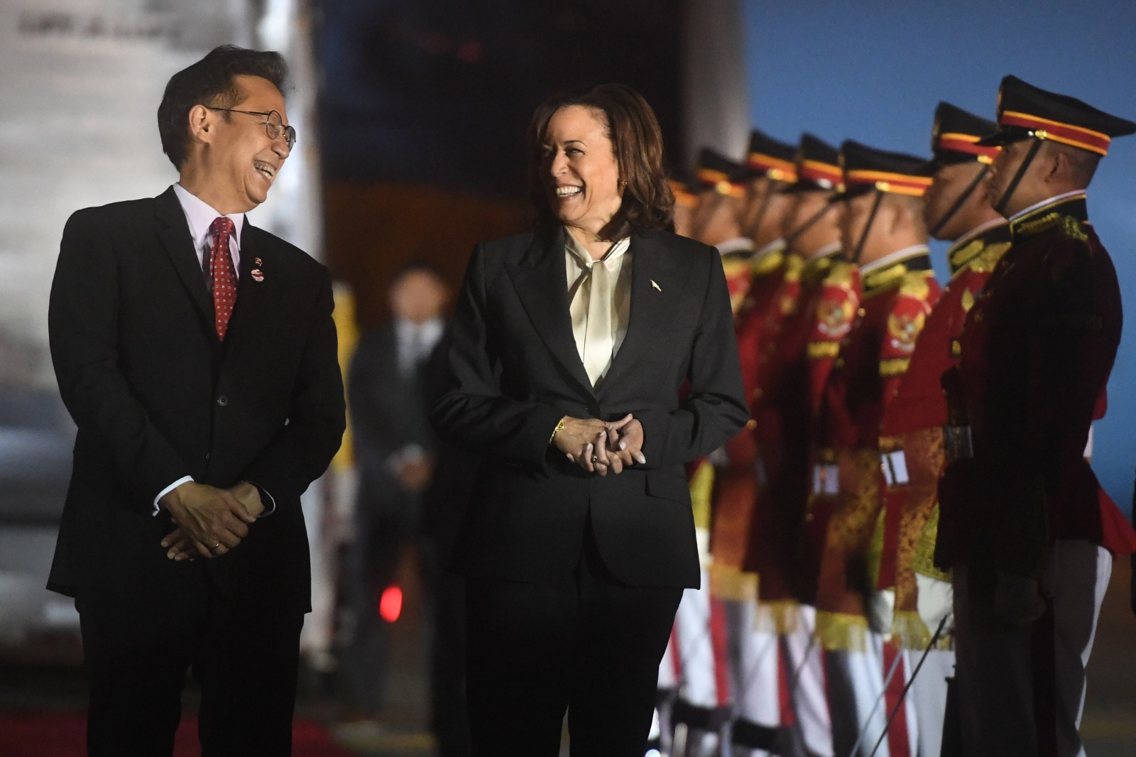

US Vice President Kamala Harris (right) is welcomed by Minister of Health Budi Gunadi Sadikin upon her arrival at Soekarno-Hatta Airport, Tangerang, Banten, Tuesday (5 September 2023). Media Center of ASEAN Summit 2023/Muhammad Adimaja/pras.

